|  |  |  |  |  |
| --- | --- | --- | --- | --- |
| **National University of Computer and Emerging Sciences, Lahore Campus** | | | | |
| C:\Users\saif\AppData\Local\Microsoft\Windows\Temporary Internet Files\Content.Word\final design.jpg | **Course Name:** | **Programming Fundamentals** | **Course Code:** | **CS 118** |
| **Program:** | **BS(CS)** | **Semester:** | **Fall 2018** |
| **Duration:** | **150 minutes** | **Total Points:** | **40** |
| **Paper Date:** | **Wednesday, 7th November 2018** | **Weight** | **25** |
| **Section:** | **G** | **Page(s):** | **2** |
| **Exam Type:** | **Lab Mid** |  |  |
| **Instruction/Notes:** | Taking some illegal online/offline help (i.e. cheating) might earn you an **F** grade in the entire course. | | | |

**Question1: (5 marks)**

A bank charges $ 15 per month plus the following check fees for a commercial checking account:

* $0.10 each for fewer than 20 checks.
* $0.80 each for 20-39 checks.
* $0.06 each for 40 or more checks.

Write a program that asks for the beginning balance and the number of checks written. Compute and display the bank’s service fees for the month.

Input Validation: number of checks and beginning balance must not be negative. In case of negative values display error message accordingly.

**Question 2: (10 Marks)**

Write a C++ program that takes an integer as input from user and displays the multiplication table till that number. In the sample given below user entered 9 as input.

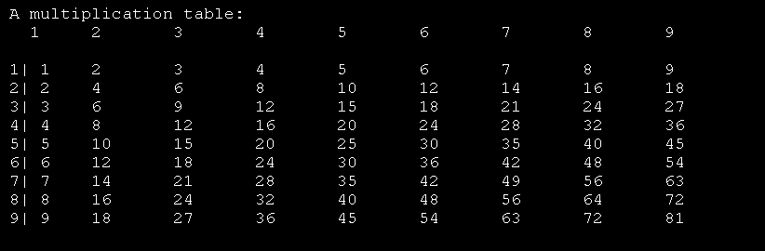

**Question 3: (10 Marks)**

Write a program that takes an integer array named array1 of size 10. Take input from user and it should not accept negative values as input. Your task is to find the number of pairs of integers in array1 whose sum is equal to the specified number. You will also take input from user the specified number. Your program should print both the pairs and their count as given in the sample output.

**Sample Output:**

Original array: 1 5 7 8 8 9 11 12 13 14

Specified Number: 12

Array pairs whose sum equal to 12:

1,11

5,7

Number of pairs whose sum equal to 12: 2

**Question 4: (15 Marks)** for this question you are required to implement three functions.

Declare a character array named string1 and populate it with following value

“my @Rollnumber& Is #678$.i Study In Fast”

1. Write a function with the prototype void ConvertToUpperCase(char string1[]), that takes the char array as parameter. This function will capitalized (upper case) the beginning of a sentence and every new sentence afterwards that starts after a full stop.
2. Write a function with the prototype void ConvertToLowerCase(char string1[]), that takes the char array as parameter. This function will convert to lower case all the words in string1 except the beginning of the sentences.
3. Write a function with the prototype void RemoveSpecialCharacter(char string1[]), that takes the char array as parameter. This function will remove all the special characters in the array. The special characters are @, $,*, #, %, !, &.

After calling all the three functions in the main program now display the contents of the array string1. Your program should not be hard coded and should work on any other char array.

Sample input: “my @Rollnumber& Is #l16781$.i Study In Fast.”

Sample output: “My rollnumber is l16781.I study in fast.”

GOOD LUCK ☺